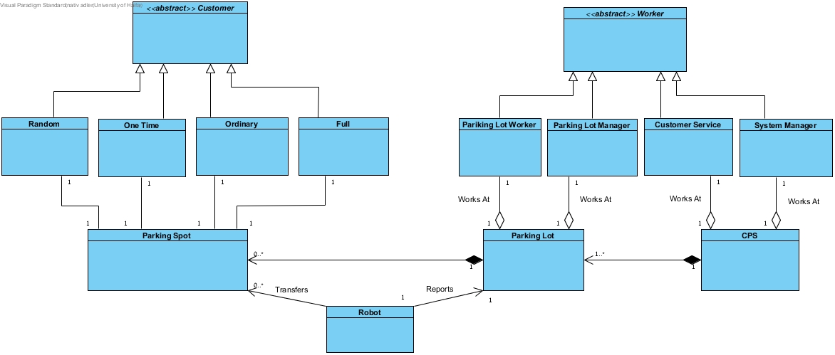

|  |  |
| --- | --- |
| מחלקה | דרישות |
| Random | 1,3,42,47,50,52 |
| oneTime | 6,4,7,8,42,47,50,52 |
| ordinary | 3,9,12,13,14,42,47,50,52 |
| Full | 3,9,12,16,15,42,47,50,52 |
| Car |  |
| Robot | 30,33 |
| parkingLot | 20,21,22,23,24,26,27,32,33,38,51 |
| CPS | 19,43,44,45,47,48,49,54,70 |
| parkingLotStats | 63 |
| parkingLotWorker | 38,39,41,57,73,76 |
| parkingLotManager | 26,57,62,73,76 |
| customerService | 41,53,57,73,76 |
| systemManager | 26,27,57,65,67,73,76 |
|  |  |
|  |  |
|  |  |